**Saarinen, Gottlieb Eliel (1873-1950)**

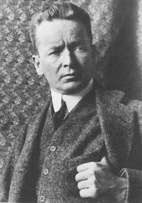

Eliel Saarinen

<http://www.robinsonlibrary.com/finearts/architecture/history/saarinen.htm>

Gottlieb Eliel Saarinen, better known as Eliel Saarinen, was an architect who practiced in his native Finland for 25 years before beginning a new phase of his career in the United States. He initially worked in a Jugendstil manner and played a central role in developing the national romanticist style that emerged in several European countries c.1890-1901. Immigrating to the USA in 1923, he gravitated towards the minimalist functionalism of the Modern Movement. Saarinen designed the campus for the Cranbrook Academy of Art and, under his stewardship, the academy became one of the most influential design schools in the country. In his later years he worked in partnership with his son Eero Saarinen, who became a leading exponent of mid-century modern architecture.

Eliel Saarinen was born in Rantasalmi, Finland. His father was a clergyman whose duties obliged him to move his family to the Ingermanland region of Russia for a time. Saarinen initially intended to be a painter, a desire that was stimulated by visits to St Petersburg’s Hermitage museum, but he enrolled in the Department of Architecture at the Technical Institute in Helsinki instead and took drawing classes at Helsinki University. In 1896, he formed an architectural partnership with fellow students Herman Gesellius and Armas Lindgren. The partnership won its first commission in 1897 for the Tallberg Apartments in Helsinki.

His first major work with the firm was the Finnish pavilion for the World’s Fair of 1900, which synthesised an extraordinary range of stylistic influences: Finnish vernacular traditions, Gothic Revival architecture, and Jugendstil. As a Grand Duchy within the Russian empire, Finland was experiencing a surge of nationalism in this era. Elias Lonnrot’s publication of national folk epic the Kalevala stimulated a revival of interest in Finland’s cultural traditions. The urge to affirm national identity and independence resulted in a style known as national romanticism, which proclaimed autonomy from Russian classicism and aimed to capture a Nordic spirit. The style was a poetic response to Finland’s glacial landscapes, vernacular building traditions and rich legacy of mythical folk tales.

In 1902 Gesellius,Lindgren and Saarinen designed a studio house for their own use at Hvitträsk, near Helsinki. Based on the traditional Finnish homestead and the British Arts and Crafts concept of a totally integrated work of art, the villa is a fine example of national romanticism. Built of logs and granite, it complements the surrounding landscape and evokes Finland's vernacular past. The internal spaces allude to medieval church interiors and are suffused with symbolism drawn from folklore and locally occurring flora and fauna.

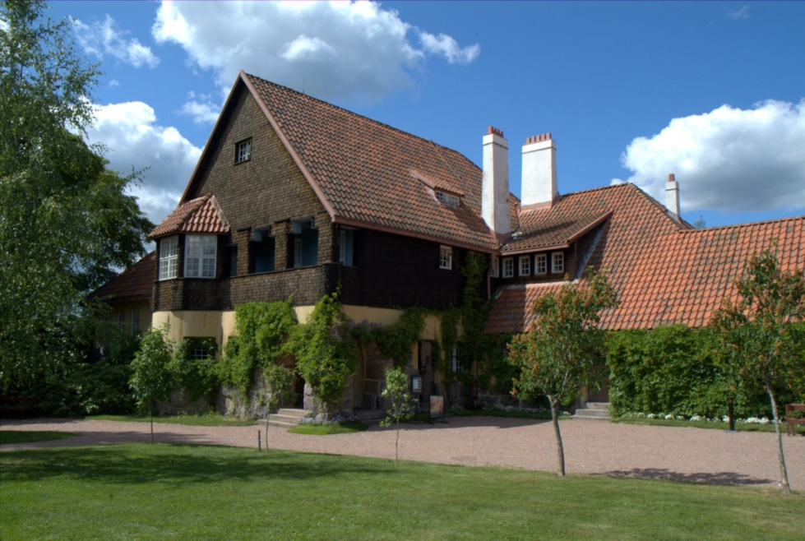

Gesellius,Lindgrenand Saarinen, studio house at Hvitträsk (1902)

<http://1.bp.blogspot.com/_j8EB-EN_Y3Q/SlxW5mdgXSI/AAAAAAAAD3Y/69uZTk0EYXo/s1600-h/University+%26+Sanitarium+%2839+of+131%29.jpg>

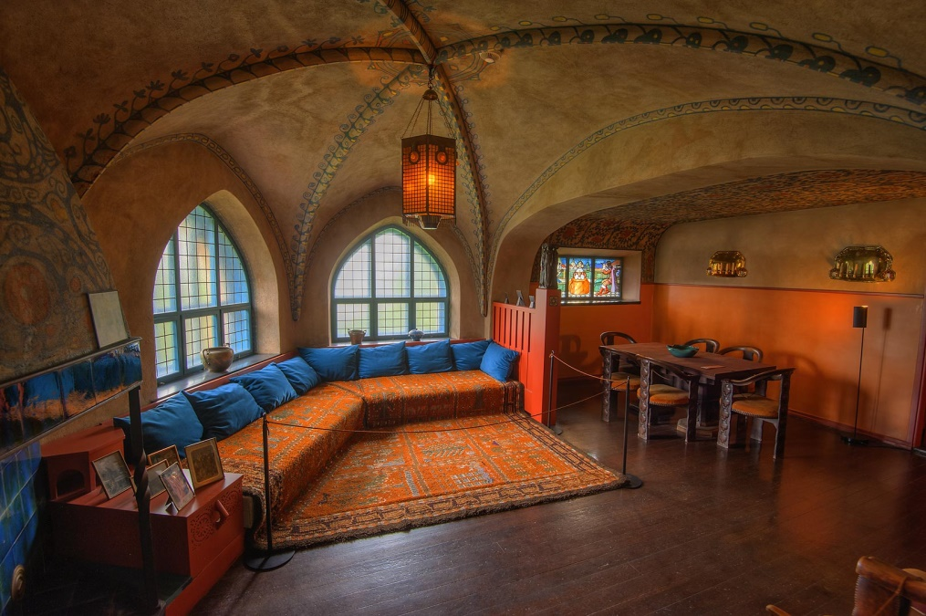

Gesellius,Lindgrenand Saarinen, studio house at Hvitträsk (1902)

<http://www.asergeev.com/pictures/archives/2015/1626/jpeg/21.jpg>

In the same spirit, the National Museum in Helsinki (1901-1911) exhibits a tactile material vocabulary of granite, brick, and hewn timber. The inventive composition is anchored around a neo-Gothic tower and the ornamentation is derived from Finnish nature and folktales.

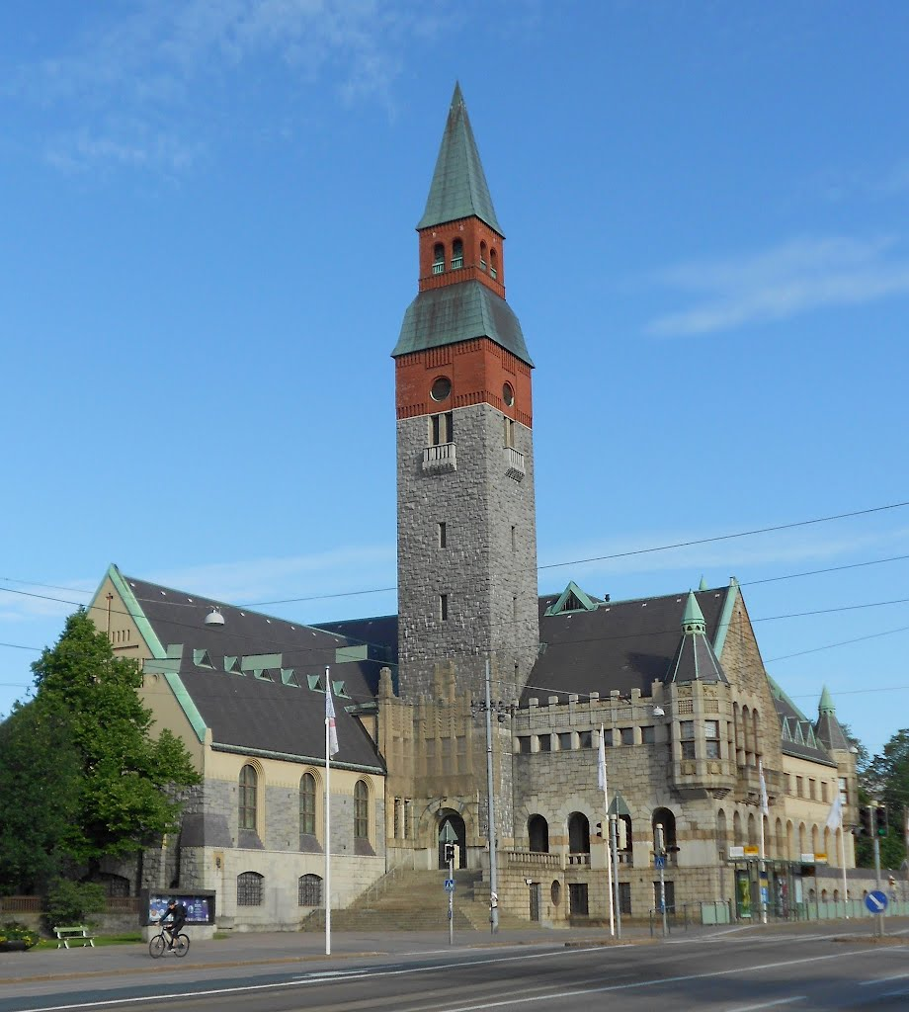

Gesellius,Lindgrenand Saarinen, National Museum, Helsinki (1904-10)

<http://static.panoramio.com/photos/large/75558805.jpg>

After divorcing his first wife, Saarinen married sculptor Louise (Loja) Gesellius, the sister of Herman Gesellius, in 1904. They had a daughter, Eva-Lisa, and a son, Eero, who was born on his own birthday. After the partnership with Gesellius and Lindgren ended in 1907, Saarinen won international acclaim for his design for Helsinki Central Railway Station, which was built in 1910-14, after a competition won in 1904. The original design was wilfully romantic, with statues of bears surmounting the façade, but Saarinen revised the design in response to criticism from the progressive architects Gustaf Strengell and Sigurd Frosterus. The completed building was almost classical in plan, with modernised jugendstil elements, abstract striations, and interiors of vaulted concrete.

Working independently, Saarinen expanded his practice to include city planning projects, devising extensive plans for the Munksnäs-Haga district of Helsinki, Reval in Estonia, and Budapest in Hungary. This last of these resulted in the publication of a book written by the architect (1912). From 1917 to 1918 Saarinen worked on the city-plan for greater Helsinki. He also designed the banknotes for Finland's currency, first in 1909 while it was still a Russian Grand Duchy, and again in 1918-19 after it become an independent nation.

The second phase of Saarinen’s career began in 1922 when he won second prize in the competition for the Chicago Tribune Tower. Although never built, his design was much admired and prompted him to immigrate to the United States in 1923. Assuming the role of design educator, he became a visiting professor at the University of Michigan. In 1925, Detroit newspaper baron and philanthropist George Gough Booth asked Saarinen to design the campus for Cranbrook Educational Community at Bloomfield Hills, Michigan (1926-43), which was conceived as an American equivalent of the Bauhaus. His buildings retain qualities of jugendstil architecture and the brick craftsmanship of Finland, but also exhibit a monumental classicising tendency that typified his work in America. Saarinen served as president of the Cranbrook Academy of Art from 1932 to 1946, and published The Cranbrook Development in 1931. Among his student-collaborators were Charles and Ray Eames, and his son Eero. His wife Loja Saarinen founded a commercial weaving studio at Cranbrook in 1928, producing rugs, curtains, and tapestries for the campus and for outside clients. The studio employed a staff of mainly Swedish women who immigrated to the USA during the 1920s and 30s.

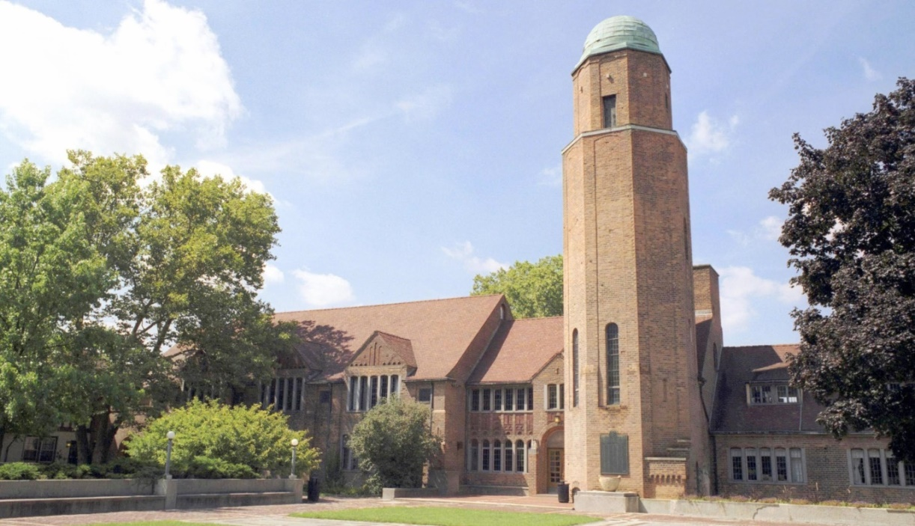

Eliel Saarinen, Cranbrook Academy

<https://i.ytimg.com/vi/65ghDoBwWww/maxresdefault.jpg>

From 1936 until his death, Saarinen was in partnership with his son, Eero, and this encouraged a turn towards the geometric simplicity of modernism. This is apparent in their best known works from this period, including the First Christian Church, Columbus, Indiana (1942), and the Christ Lutheran Church in Minneapolis (1949), both using dramatic tower typologies. Saarinen died in Michigan in 1950, and is buried at Hvitträsk, Finland. His son Eero became one of the most important American architects of the mid-20th century.

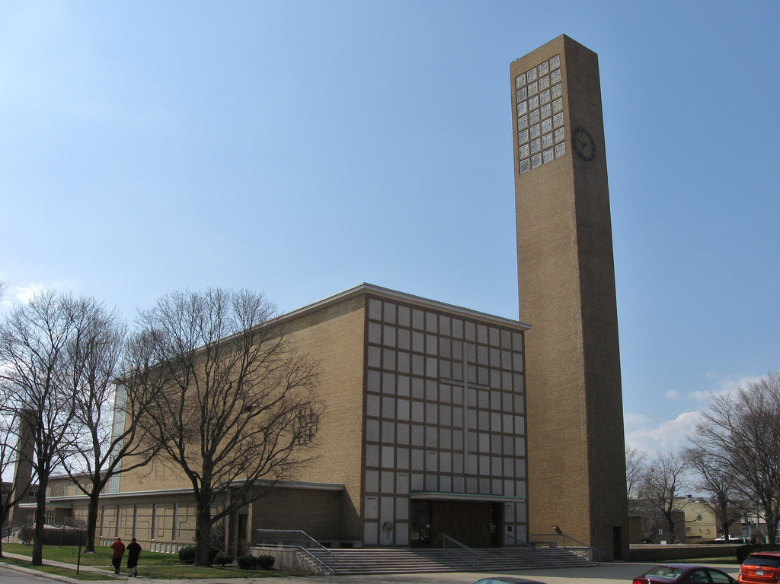

Eliel and Eero Saarinen, First Christian Church, Columbus, Indiana (1942)

<https://c1.staticflickr.com/5/4048/4516697506_824d3eb9f2_b.jpg>

**Selected Works**

Gesellius,LindgrenandSaarinen,Tallberg Apartments, Helsinki, 1897

Gesellius,Lindgren andSaarinen, Finnish pavilion for the World’s Fair, 1900

Gesellius,Lindgrenand Saarinen, Studio house at Hvitträsk, Kirkkonummi, 1902

Gesellius,Lindgrenand Saarinen, National Museum of Finland, Helsinki, 1904

Eliel Saarinen, Helsinki Central railway station, Helsinki, 1909

Eliel Saarinen, Lahti Town Hall, Lahti, 1911

Eliel Saarinen, Vyborg railway station, Vyborg, 1913

Eliel Saarinen, Joensuu Town Hall, Joensuu, 1914

Eliel Saarinen, Saint Paul's Church, Tartu, 1917

Eliel Saarinen, Marble Palace, Helsinki, 1918

Eliel Saarinen, Munkkiniemi Pension house, Helsinki, 1920

Eliel Saarinen, Cranbrook Educational Community, Bloomfield Hills, Michigan, 1926-43

Eliel and Eero Saarinen, Kleinhans Music Hall, Buffalo, 1940

Eliel and Eero Saarinen, Crow Island School, Winnetka, 1940-41

Eliel and Eero Saarinen, First Christian Church, Columbus, Indiana, 1942

Eliel Saarinen, Des Moines Art Center, Des Moines, 1948

Eliel and Eero Saarinen, Christ Church Lutheran, Minneapolis, 1949

**Further Reading**

Belloli, Andrea P. A; Clark, Robert Judson (1983) Design in America: the Cranbrook vision, 1925-1950. Detroit: Detroit Institute of Arts.

Christ-Janer, Albert (1979) Eliel Saarinen: Finnish-American architect and educator. Chicago: University of Chicago Press.

Saarinen, Eliel; Hausen, Marika (1990) Eliel Saarinen: projects 1896-1923. Cambridge, Mass.: MIT Press.

Svinhufvud, L. (2012) ‘The Politics of Textile Entrepreneurship Loja Saarinen and Her Weaving Studio in the Cranbrook Art Community’*, Textile Society of America Symposium Proceedings*.

Michael Johnson

Northumbria University